PE_PRN221_SP24_TrialTest
SPRING 2024
Subject: PRN221
Duration: 90 minutes

INSTRUCTIONS
Please read the instructions carefully before doing the questions.
- You are NOT allowed to use any other materials. You are NOT allowed to use any device to share data with others.
- You must use Visual Studio 2019 or above, MSSQL Server 2008 or above for your development tools.
IMPORTANT – before you start doing your solution, MUST do the following steps:
- Create Solution in Visual Studio named PRN221PE_SP24_TrialTest_StudentName. Inside your Solution, the Project ASP.NET Core Razor Page must be named: Eyeglasses_StudentName.
- Create your MS SQL database named Eyeglasses2024DB by running code in script Eyeglasses2024DB.sql.
- Set the default user interface for your project as Login page.
- To do your program, you must use ASP.NET Core Razor Pages. Note that you are not allow to connect direct to database from Razor Pages, every database connection must be used through Repository and Data Access Objects. The database connection string must get from appsettings.json file.
In the case your code connects directly to database from ASP.NET Core Razor Pages or you hardcode connection string, you will get 0 mark.
- If there are syntax errors or compilation errors in your PE program, you will not pass the PE requirements, the mark will be 0.

Create an application using ASP.NET Core Razor Pages with .NET Core (.NET 5 or .NET 6), C#, and ADO.NET (or Entity Framework Core). A MS SQL Server database will be created to persist the data and it will be used for reading and managing data.
A part of Eyeglasses2024DB database.
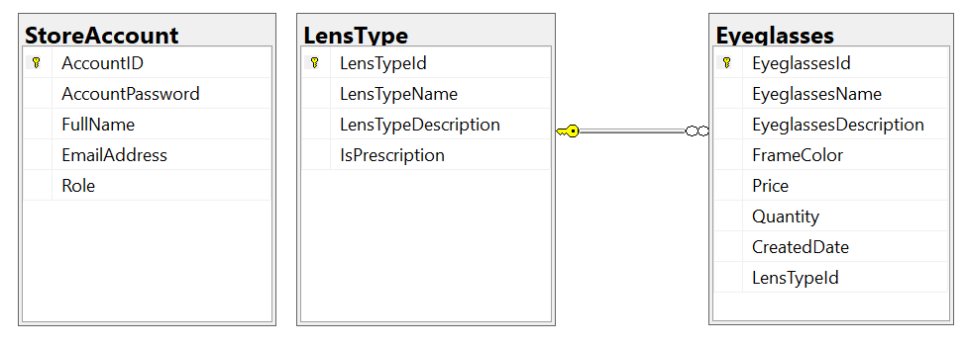
Store account role: Administrator = 1; Staff = 2; Manager = 3; Customer = 4

- (1.0 mark) Authentication function. Using EmailAddress and Password for authentication process.
If user with a Administrator Role or Staff Role logs in successfully, save this information to a temporary parameter. In the case login unsuccessfully, display “You do not have permission to do this function!”.
- All CRUD actions are required with Administrator Role,
- Staff Role is required for only Read action.

- (2.0 marks) Check if login successfully (Staff or Administrator role), list all eyeclasses information in Eyeglasses table (each record includes information of eyeglassess and LensTypeName). Pagging is required for this function, 4 records/1page.

- (1.0 mark) If user with a Administrator role logs in successfully, search all eyeglasses with 2 conditions: Price, EyeglassesDescription (OR option for this case and using relative search).

- (1.0 mark) If user with a Administrator logs in successfully, delete the selected item with the confirmation then update the list of eyeglasses.

- (3.0 marks) If user with a Administrator role logs in successfully, add a new item with the requirements:
- The new item will display in top of the list.
- All fields are required.
- Value for Quantity <= 999 and >= 0.
- Value for eyeglasses’ name is greater than 10 characters. Each word of the EyeglassesName must begin with the capital letter. EyeglassesName is also allowed with number (0, 1, 2 →9) or special characters such as @, #, $, &, (, ).
- Value for CreatedDate is the time when create eyeglasses and set default value for CreatedDate = current date. CreatedDate can’t update.

- (2.0 mark) If user with a Administrator logs in successfully, update the selected existing item.
- With update function, the same validation requirements with Add function.

